SARANA: A Programming Language User Manual
Serena Morris- 2208659, Raheem Gordon – 2208501, Chadrick Atkinson- 2204885, Akeem Creary - 2110275
University of Technology, Jamaica
CIT4004: Analysis of Programming Languages
Mr. David W. White
April 10, 2026

Table of Contents
1. Introduction 3
2. Application Overview 3
3.1 Pages 5
3.2 Sample Programs 6
3.3 Compiler Options 7
3.4 LLM Integration 7
3.5 Language Reference (Sidebar Quick Reference) 8
Keywords 8
Operators 9
4. Writing and Running Code 10
4.1 The Code Editor 10
4.3 Clearing the Editor 10
5. Output Tabs 10
5.1 Output Tab 10
6. Language Docs Page 16
6.1 Sarana Language Reference Overview 16
6.2 Language Characteristics 17
6.4 Output 17
6.5 Arithmetic 18
6.6 Comparison Operators 18
6.7 Conditionals 19
6.9 Functions 19
6.10 Exception Handling 20
6.11 Boolean Logic 20
6.12 Arrays 21
6.13 Comments 21
6.15 Grammar Summary (EBNF) 22
6.17 Error Types 24
7. Tips for Getting Started 25
8. Troubleshooting 25

1. Introduction
This manual covers the Sarana Language Playground. Sarana is a Caribbean and nature-inspired, high-level, general-purpose programming language.
You can write, run, and test Sarana programs directly in your browser with no setup needed. The playground walks you through each stage of the compiler pipeline, from tokenisation and the Abstract Syntax Tree (AST), all the way to generated Python code
Host Link: https://python-sarana.streamlit.app

2. Application Overview
Opening the Sarana Playground brings up the main interface shown below. The layout splits into two areas: a sidebar on the left for navigation and settings, and a main panel on the right where you write and run code.
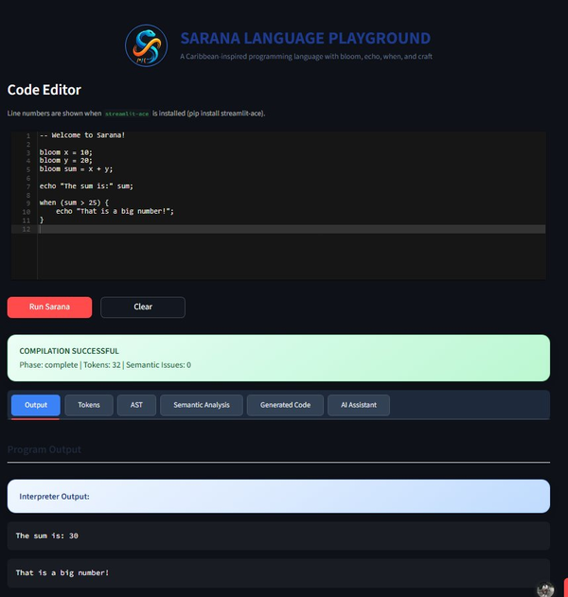
Figure 1 - The Sarana Language Playground main interface
The main interface consists of the following key areas:
- Code Editor: Where you write your Sarana program
- Run Sarana button (red): Compiles and executes your code
- Clear button: Clears the editor
- Compilation Status banner: displays whether execution was successful or if errors occurred
- Output Tabs: Including Output, Tokens, AST, Semantic Analysis, Generated Code, and AI Assistant
- Sidebar: Provides access to navigation, sample programs, compiler options, and language reference
3. The Sidebar
Your control panel for the playground is on the left. Navigation, settings, and the language reference are all tucked in the sidebar.
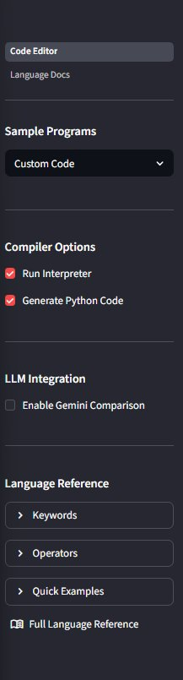
Figure 2 - The sidebar navigation panel

3.1 Pages
At the top of the sidebar, there are two pages available for navigation:
- Code Editor - the main page for writing and executing Sarana code (default view)
- Language Docs - the complete Sarana language documentation and reference page

3.2 Sample Programs
Use the Sample Programs dropdown to load a pre-written example directly into the editor. It’s the fastest way to see Sarana in action before writing your own code.
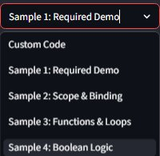
Figure 3 - Sample Programs dropdown
The available programs include:
- Custom Code - a blank editor where you can write your own programs:
- Sample 1: Required Demo - shows the main Sarana features like variables, arithmetic, and exception handling
- Sample 2: Scope & Binding - focuses on how variable scope works and how functions are bound
- Sample 3: Functions & Loops - demonstrates how functions are created and how loops operate
- Sample 4: Boolean Logic - shows how Boolean expressions work, including short-circuit evaluation
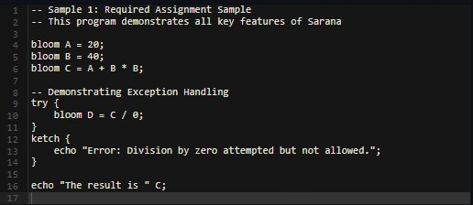
Figure 4 - Sample 1: Required Demo loaded in the editor

3.3 Compiler Options
Compiler Options controls what happens when you hit Run Sarana:
- Run Interpreter - if checked, your program runs and the output shows up in the Output tab
- Generate Python Code - if checked, Sarana converts your code into Python, which you can see in the Generated Code tab

3.4 LLM Integration
LLM Integration hooks the playground up to Google Gemini. Enable Gemini Comparison, drop in your API key, and the AI Assistant tab becomes available. From there it can walk through your code, contrast it with Python, and point out spots worth improving.

3.5 Language Reference (Sidebar Quick Reference)
The Language Reference panel keeps Sarana’s syntax within reach while you code. Three expandable sections cover the basics:

Keywords
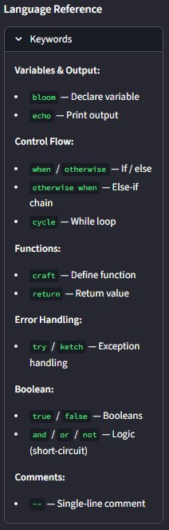
Figure 5 - Keywords quick reference in the sidebar

Operators
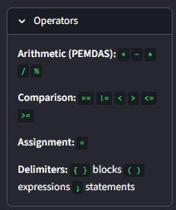
Figure 6 - Operators quick reference in the sidebar
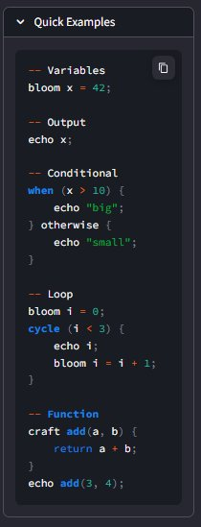
Figure 7 - Quick Examples in the sidebar

4. Writing and Running Code

4.1 The Code Editor
The Code Editor is where your Sarana programs take shape. It includes syntax highlighting and line numbers. You can type directly or pull in one of the samples from the sidebar.
4.2 Running Your Code
When your program is ready, click the red Run Sarana button. The playground compiles and executes it, then displays the results in the Output panel.
After running, a status banner will appear:
- Green banner - COMPILATION SUCCESSFUL: your code compiled and ran without errors. The banner shows the phase reached, total tokens, and any semantic issues.
- Red banner - COMPILATION FAILED: there’s an error in your code. Check the error message for details.

4.3 Clearing the Editor
Click the Clear button next to Run Sarana to erase all code from the editor and start fresh.

5. Output Tabs
After running your code, the results appear across six tabs. Each tab shows a different stage of the compiler pipeline, and you can click any tab to see its output

5.1 Output Tab
The Output tab is where your program’s results appear. Anything printed with the echo statement shows up here under "Interpreter Output".

Figure 8 - Output tab showing interpreter result
5.2 Tokens Tab
The Tokens tab shows what came out of the Lexical Analysis phase. The lexer breaks your source into individual tokens, and each one gets a type, a value, and the line number where it appeared.

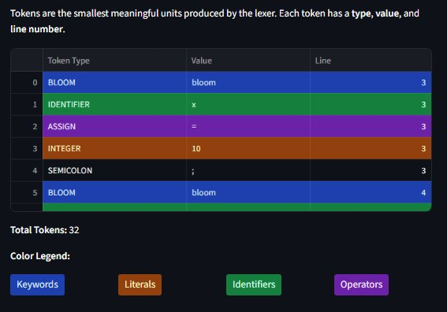
Figure 9 - Tokens tab showing lexical analysis output
Tokens are colour-coded by category:
- Blue - Keywords (like bloom, echo, when, craft)
- Brown/Orange - Literals (numbers and strings)
- Green - Identifiers (variable and function names)
- Purple - Operators (like +, =, ==)
A total token count and colour legend appear below the table.
5.3 AST Tab
The AST tab is the Syntax Analysis phase output. The compiler parses your code and builds a tree where each node corresponds to a grammar rule. That tree is what you’re looking at.
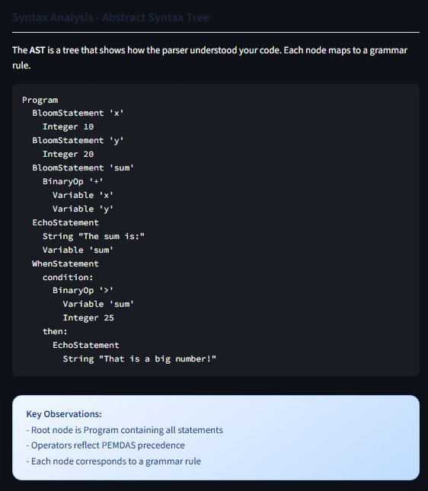
Figure 10 - AST tab showing the Abstract Syntax Tree
Key observations shown at the bottom of the tab:
- The root node is always Program, which contains all statements
- Operators follow PEMDAS precedence in the tree
- Each node matches a grammar rule from Sarana’s language definition
5.4 Semantic Analysis Tab
The Semantic Analysis tab is where logical errors get caught after the parser passes. Undefined variables, type mismatches, division by zero, calls to undeclared functions, that sort of thing.
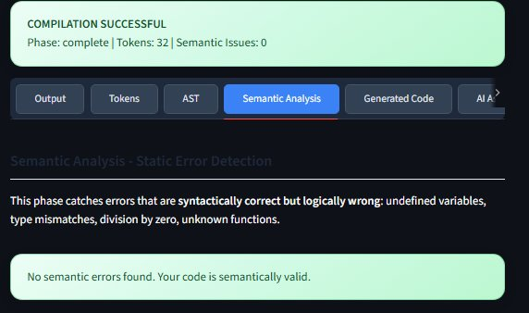
Figure 11 - Semantic Analysis tab showing static error detection
If your code is valid, you will see: "No semantic errors found. Your code is semantically valid." If issues exist, they are listed so you can correct them before running.
5.5 Generated Code Tab
The Generated Code tab shows the Python output from Target Code Generation, which is the last step in the pipeline. Sarana’s AST gets translated into equivalent, runnable Python.
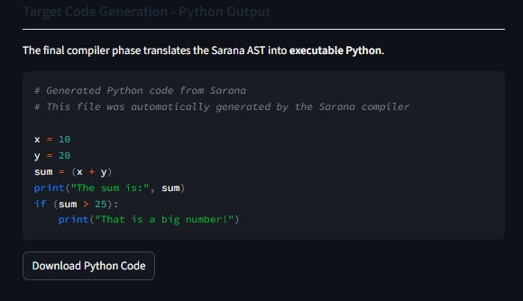
Figure 12 - Generated Code tab showing the Python output

You can click the Download Python Code button to save the generated Python file to your computer.
5.6 AI Assistant Tab
The AI Assistant tab runs your code through Google Gemini. It can break down what the program does, show the Python equivalent, spot bugs, and suggest improvements.
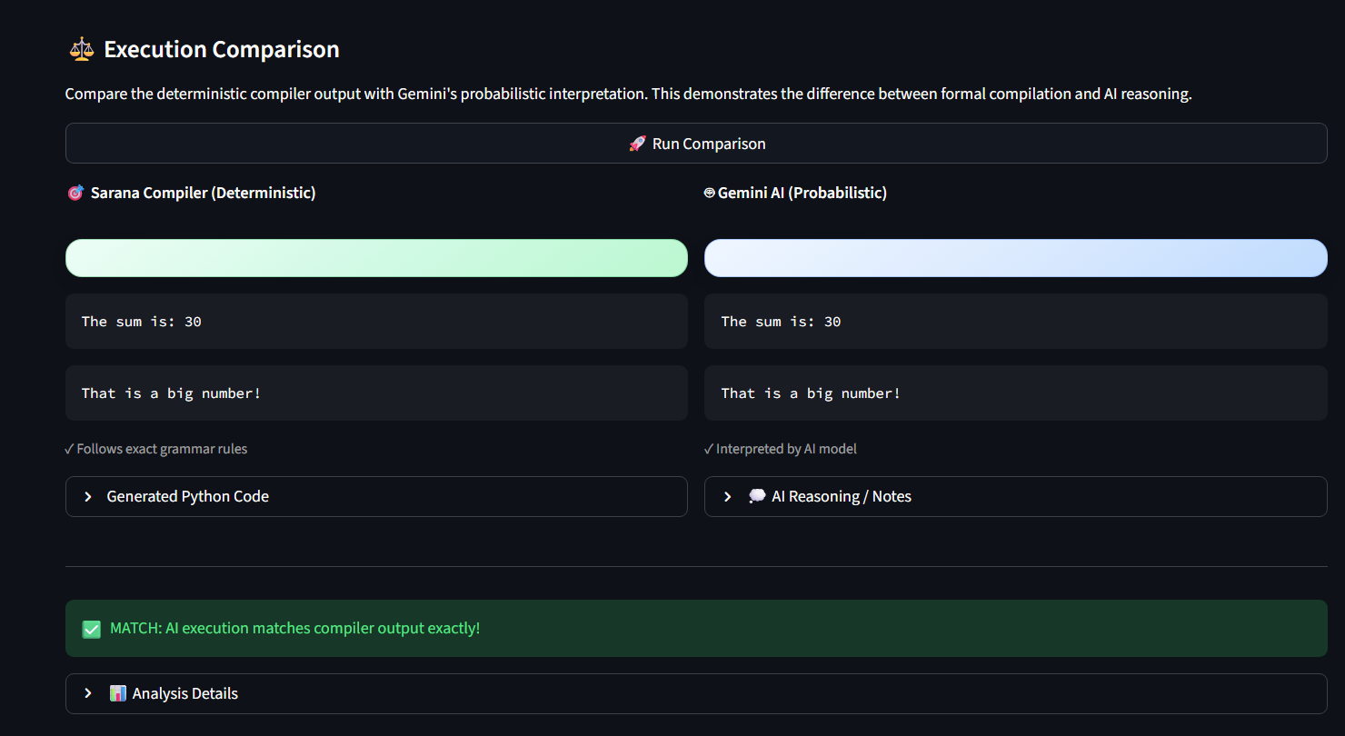
Figure 13 - AI Assistant tab powered by Gemini
To activate the AI Assistant:
- In the sidebar, check Enable Gemini Comparison under LLM Integration
- Enter your Gemini API key when prompted or set the GEMINI_API_KEY environment variable before starting Stream lit
- Run your code and click the AI Assistant tab to see the AI analyze

6. Language Docs Page
The Language Docs page is the full reference for Sarana. Click Language Docs in the sidebar to get there. It covers every part of the language across 16 sections.

6.1 Sarana Language Reference Overview
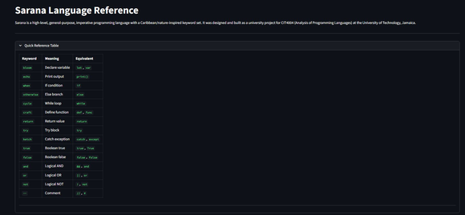
Figure 14 - Language Docs page header and Quick Reference Table
The Quick Reference Table at the top maps every Sarana keyword to its meaning and its equivalent in other languages. It’s a solid starting point when getting familiar with Sarana’s syntax.

6.2 Language Characteristics
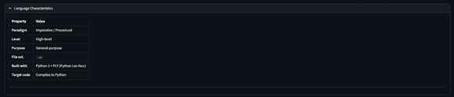
Figure 15 - Language Characteristics table
Sarana is a high-level, general-purpose, imperative and procedural language built with Python 3 and PLY. Programs use the .sa file extension and compile down to Python as the target output.
6.3 Variables
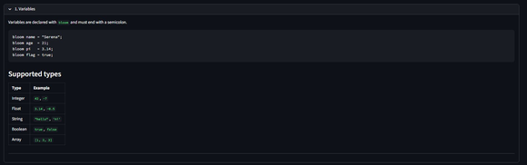
Figure 16 - Variables section
Variables are declared with bloom and must end with a semicolon. Sarana recognizes five data types: Integer, Float, String, Boolean, and Array.

6.4 Output
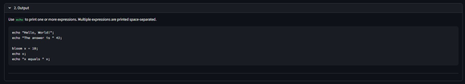
Figure 17 - Output section
echo prints one or more values to the screen. Spaces separate multiple expressions in a single echo call.

6.5 Arithmetic
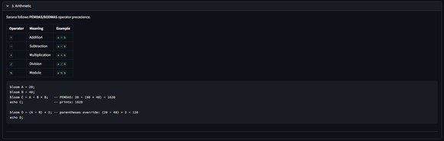
Figure 18 - Arithmetic operators section
Sarana includes the five standard arithmetic operators: +, -, *, /, and % (modulo). Operator precedence follows PEMDAS/BODMAS, and parentheses can override the default order.

6.6 Comparison Operators
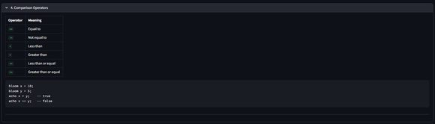
Figure 19 - Comparison operators section
Six comparison operators are available: == (equal), != (not equal), < (less than), > (greater than), <= (less than or equal), and >= (greater than or equal). All return true or false.

6.7 Conditionals
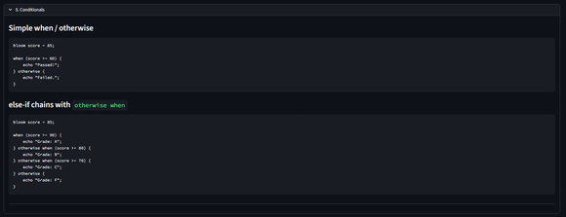
Figure 20 - Conditionals section
Conditionals use when and otherwise for if/else logic, with blocks wrapped in curly braces {}. Chain multiple branches with otherwise when for else-if behaviour.
6.8 Loops
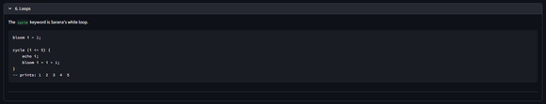
Figure 21 - Loops section
cycle is Sarana’s while loop. It keeps running a block as long as the condition holds. The condition goes in parentheses; the body goes in curly braces {}.

6.9 Functions
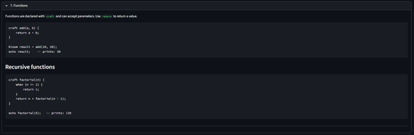
Figure 22 - Functions section
Declare functions with craft. They can take parameters and return values with return. Recursion works as expected. The factorial example in the docs demonstrates this.

6.10 Exception Handling
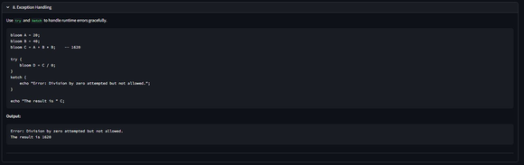
Figure 23 - Exception Handling section
try and ketch handle runtime errors without crashing. The try block runs normally; if something goes wrong, control jumps to the ketch block instead.

6.11 Boolean Logic
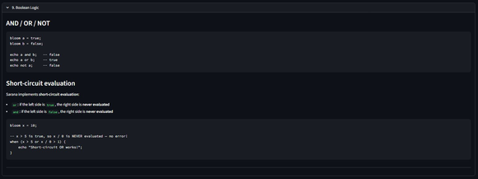
Figure 24 - Boolean Logic section
Logical operations use and, or, and not. Short-circuit evaluation applies: in an or expression the right side is skipped when the left is already true; in an and expression the right side is skipped when the left is false.

6.12 Arrays
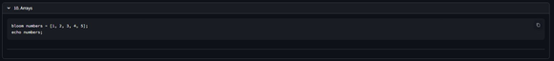
Figure 25 - Arrays section
Arrays use square bracket [] syntax and are assigned with bloom. They can hold a mix of different value

6.13 Comments
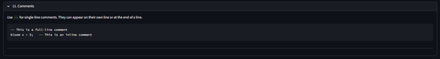
Figure 26 - Comments section
Single-line comments start with --. They work on their own line or tacked onto the end of any line of code.
6.14 Complete Example Programs
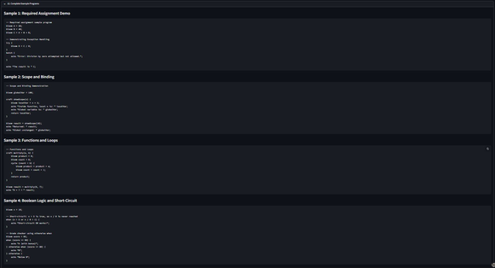
Figure 27 - Complete example programs on the Language Docs page
Four complete, runnable programs are included on the Language Docs page: Required Assignment Demo, Scope and Binding, Functions and Loops, and Boolean Logic. Copy any of them into the Code Editor and run them directly.

6.15 Grammar Summary (EBNF)
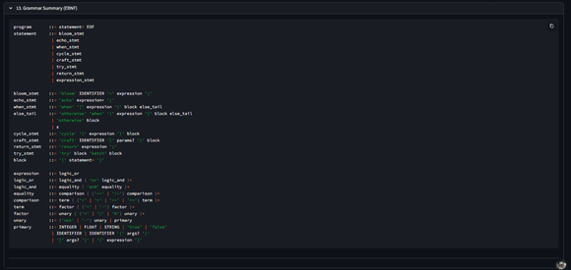
Figure 28 - Grammar Summary in EBNF notation
The grammar section lays out Sarana’s formal syntax in EBNF (Extended Backus-Naur Form), covering every rule the parser uses to interpret your code.
6.16 Token Reference
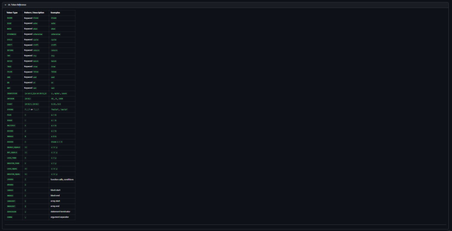
Figure 29 - Token Reference table
The Token Reference table covers every token type in Sarana its pattern or description and worked examples. It’s the right place to look when you’re trying to make sense of the Tokens tab output.

6.17 Error Types
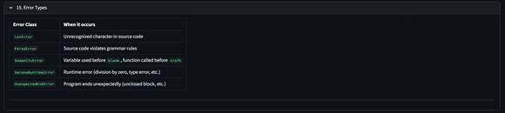
Figure 30 - Error Types reference table
Five error classes can surface in Sarana:
- LexError - an unrecognized character was found in your source code
- ParseError - your code breaks the grammar rules
- SemanticError - a variable is used before bloom, or a function is called before craft
- SaranaRuntimeError - a runtime error like division by zero or a type error
- UnexpectedEndError - the program ends unexpectedly, usually because a block {} wasn’t closed
6.18 Nine Characteristics of a Good Programming Language
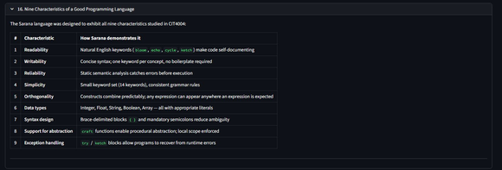
Figure 31 - Nine Characteristics of a Good Programming Language
Sarana was designed with the nine characteristics of a good programming language from CIT 4004 in mind: Readability, Writability, Reliability, Simplicity, Orthogonality, Data types, Syntax design, Support for abstraction, and Exception handling. This section walks through how each one is addressed.

7. Tips for Getting Started
- Start with a sample program from the sidebar dropdown. It’s the quickest way to see working Sarana code
- The Tokens tab is your best friend for debugging syntax errors. It shows exactly how the lexer reads your code
- If the code compiles but behaves unexpectedly, open the Semantic Analysis tab to see if anything was flagged
- The Generated Code tab is worth studying. Comparing Sarana syntax against its Python output is one of the better ways to understand both
- The Language Reference panel in the sidebar stays visible while you code, treat it as a cheat sheet
- For the full language reference grammar rules, error types, and complete programs, click Language Docs in the sidebar
- Running with both Run Interpreter and Generate Python Code checked gives you the full picture in a single pass

8. Troubleshooting
Problem | Solution
Red "COMPILATION FAILED" banner | Check for missing semicolons ;, unclosed curly braces {}, or misspelled keywords. Use the Tokens tab to see exactly where the error happened.
Output tab is empty | Make sure Run Interpreter is checked in Compiler Options in the sidebar and that your code uses echo to print output.
Generated Code tab is empty | Make sure "Generate Python Code" is checked in Compiler Options in the sidebar before running.
AI Assistant says to enable Gemini | Check "Enable Gemini Comparison" in LLM Integration in the sidebar and enter a valid Gemini API key.
SemanticError: variable used before bloom | Declare your variable with bloom before using it anywhere in your program.
Division by zero crashes the program | Wrap the division in a try / ketch block to handle the error gracefully.
Code runs but prints nothing | Confirm you are using echo to output values. Expressions without echo do not produce visible output.
UnexpectedEndError | You likely have an unclosed block. Check that every opening { has a matching closing }.

